**Review Questions – Part 2**

NOTE: Use python shell to confirm your answers for syntax questions 1. What is the look of this flowchart when finished?

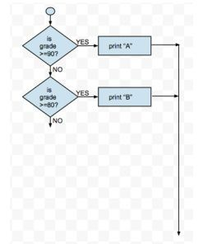

The look of this flow chart would be checking grade if it is greater than every ten numbers, then printing a print for the letter grade. Then it will say end.

1. What does the program for that flowchart do? Write the full program.

The program for the flow chart prints the letter grade for the percent entered.

grade = int ( input (‘Please enter your grade’)) if grade <= 100 and grade >= 0: if grade <= 90: print (‘A’) if grade <= 80: print (‘B’) if grade <= 70: print (‘C’) if grade <= 60: print (‘D’) if grade <= 50:

print (‘F’)

1. How do you use the range function to print the integers from 34 through 41 inclusive?

for x in range (34, 42): print (x, end = ‘ ‘)

1. How do you tally all the integers from 34 through 41 inclusive? Show code.

tally = 0 for x in range (34, 42): tally = tally + x print (tally)

1. Identify the accumulator variable in your code for question 4.

The accumulator variable is tally.

1. Write the code to prompt the user for an integer, N. How do you display a square pattern of asterisks N by N? Show code:

n = int (input ('Please enter a variable n:')) for x in range (n): for x in range (n):

print ('*', end = ' ')

print ('')

1. Write the code to print all even integers from 36 through 12 inclusive.

for x in range (36, 10, ­2):

print (x, end = ' ')

1. Write the code for a while loop to prompt the user if he or she wants to continue to input more integers. Bold/underline the condition expression in the code. **while yesNo == 'yes' or yesNo == 'Yes'**​:

integer = int (input ('Please enter an integer:'))

yesNo = input ('Do you want to enter another integer? (yes/no):')

The following questions are related to this flowchart:

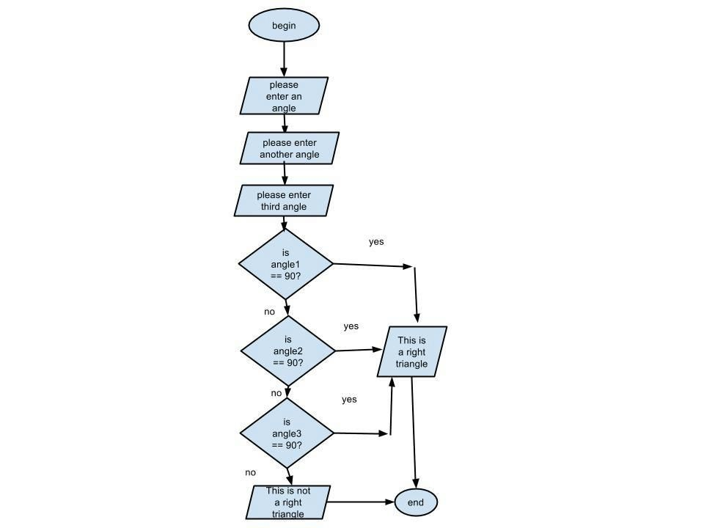

9.​​What does the oval shape represent?

It shows where the program begins and ends.

1. Explain in a complete sentence (or two), what this program will do.

It takes 3 angles from the user and checks if any of the angles equal 90. It then prints if the angles form a right triangle or not.

1. Draw a flowchart for the PHS age program.

Begin

Enter the

age of PHS

Is age

116?

== 116

no

yes

print (incorrect,

try again)

Enter the

age of PHS

print

(

Correct

)

End

1. Rewrite this while loop as a FOR loop:

**x = 5 ­(1) while x < 25: ­(2) print(“*”, end=” “)**

**x = x + 3 ­(3)**

for x in range (5,25,3): print (‘*’, end = ‘ ‘)

1. What are the three actions every loop must execute? Label each action (1, 2, 3) on the while loop in question 12.

* 1. Define a variable.
  2. Include the variable in the condition statement
  3. Contain a way to change the variable so the loop con end.

1. Rewrite this FOR loop as a while loop. Highlight the accumulator variable.

What does “\n” do?:

**total = 0**

**for z in range(1, 15, 2): total = total + z**

**print(total, end=”\n”)**

|  |  |
| --- | --- |
| total = 0 | |
| z = 1 |  |

while z < 15: total = total + z print (total, end=”\n”) z = z + 2

“\n” starts a new line, which has no impact on this problem.

1. What structure can be used to repeat a block of statements when the termination of the loop is not known? Explain your answer.

A for loop can be used to repeat a block of code when the termination of the loop is unknown. You can put a variable in the range function to run it that undetermined number of times.

1. What structure can be used to repeat a block of statements when the termination of the loop is known? Explain your answer.

Either a while of for loop could be used because you can have an accumulator variable telling the while loop when to stop running, you can also have a fixed range in the for loop.